INTRODUCTION

- Pre-processor commands
- Function
- Variables
- Comment

COMPILATION

Pre processing => Compilation => Assembly => Linking => Load

- Pre processing(.i file): comment removed, macros expanded #include files content is saved in a file[.i].
- Compiling(.s file): .i file is converted to assembly language instruction.
- Assembly(.o file): .s file is converted to machine level instructions [.o].
- Linking: linking .s file to single.

Tokens: basic building blocks
e.g: printf, {}
Keywords, identifiers, constants, symbols, string literals

NOTE: white spaces do not matter while programming

Variable:
memory location
Declared by writing type variable_name
Initialized and declared by: type variable_name = value;

Rules for defining a variable in C
- Alphabets, digits, underscore(_) accepted
- Start with alphabet or underscore only(_)
- Can’t start with a digit
- No whitespace or reserved keyword allowed
- No special symbol can be used[like: . , / $ # etc..]

Data types in C
- Basic data type: int, char float, double.
- Derived data type: array, pointer, structure, union
- Enumeration data type: enum
- Void data type: Void

Basic Operators and functions
+, -, *, /, etc…
Int a;
Scanf(“%d”,&a);
printf(“%d”, a);

OPERATORS:
- Arithmetic operator: +, -, *, /, etc..
- Relational operators: ==, >=, <=, !=
- Logical operator: &&, ||, !, etc..
- Bitwise operator: &, |, ^
- Assignment Operator: =, -=, +=, *=, /=
- Miscellaneous Operator:
    - sizeof(): returns the size of a variable
    - &: returns address of a variable
    - *: pointer to a variable
    - ?: Conditional expression
What is a pointer?

- Variable which stores the address of another variable
- Can be of type int char, array, function, or any other pointer
- Size depends on the architecture. Ex 2 bytes for 32 bit
- Pointer in C programming language can be declared using*

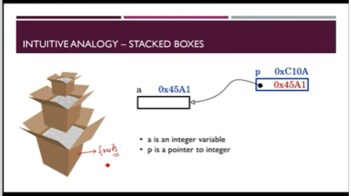

‘&’ and ‘*’ operator

&: Address of operator
&a ==> represents the address of a

*: Dereference operator, or indirection operator
*ptr ==> represents the value of the term to which this pointer is pointing
TUTORIAL 29 NOTES

WHY WAS RECURSIVE APPROACH SLOWER IN CASE OF FIBONACCI SERIES

we called:
fib(0) played once
fib(1) played once
fib(2) sum of 0 and 1 played once
fib(3) sum of 2 and 1 played once
fib(4) sum of 3 and 2 played once

Note how many times each fib is calculated: too many redundant calls
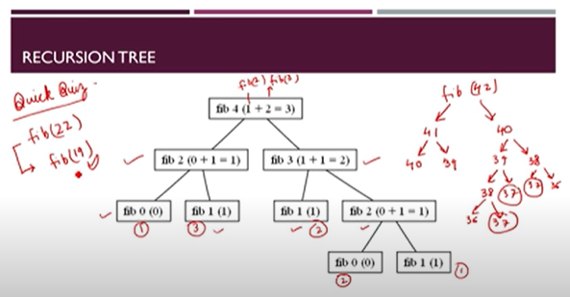
Unnecessary increase of time complexity

IN A NUT SHELL

- Recursions is a good approach when it comes to problem solving
- However, programmer need to evaluate the need and impact of using recursive/ iterative approach while solving a particular problem
- In case of factorial calculation, recursion saved a lot of lines of code
- However in case of Fibonacci series, recursion resulted in some extra unnecessary function calls which was an extra overhead!
- Running time for fibonacci series grows exponentially with input in case of recursive approach!
FUNCTIONS: CALL BY VALUE AND CALL BY REFERENCE

Actual and Formal parameters

- When a function is called, the values(expressions) that are passed in the call are called the arguments or actual parameters
- Formal parameters are local variables which are assigned values from the arguments when the function is called

Int add(int a, int b){
Int y;
Return a+b;
}
Int main(){
Int x =1, y =11 ;
Int s = add(x, y);
}

Here x and y are actual parameters(arguments) while a and b are formal parameters(parameters)

Types of functions calls in C programming

- In C programming language, we can call a function in two different ways, based on how we specify the arguments. These two ways are:
  - Call by value: the values of actual parameter is sent to formal
  - Call by reference : address is sent to formal editing this will change the original x and y because we are sending address

Call By Value
- When we call a function by value, it means that we are passing the values of the arguments which are copied into the formal parameters of the function
- Which means that the original values remain unchanged and only the parameters inside the function changes

Call By Reference
- The call by reference method of passing arguments to a C function copies the address of the arguments into the formal parameters
- Address of the actual arguments are copied and then assign to the corresponding formal arguments

Int func(int *a){
return 0;
}
Int main(){
func(&a);
}

EXAMPLE

#include <stdio.h>
void( int *x, int *y){
temp = *x ;
*x = *y ;
*y = temp;
}

int main(){
int a = 34, b = 74;
printf(“%d and %d \n”, a, b);
Swap(&a, &b);
printf(“%d and %d \n”, a, b);

Return 0;
}
TUTORIAL 32

Why and how to pass arrays ?

  - We pass arrays to a function when we need to pass a list of values to a given function
  - We can pass arrays to a function
    - By declaring array as a parameter in the function
    - By declaring a pointer in the function to hold the base address of the array

By declaring array as a parameter in the function

Int func(int arr[]){
For…{
Sum = sum + arr[i];
}
return sum/s;
}
Int main(){
Int arr[] = {1, 2, 3, 4};
Int arr = func(arr);
Return 0;
}

NOTE: Inside func if you change the value of the array it gets reflected in the main function

By passing array’s base address to the function

Int avg(int *ptr){
*(ptr + 1) ---> gives 2
*(ptr + 2) ---> gives 3
}

Int main(){
avg = func(arr);
Return 0;
}

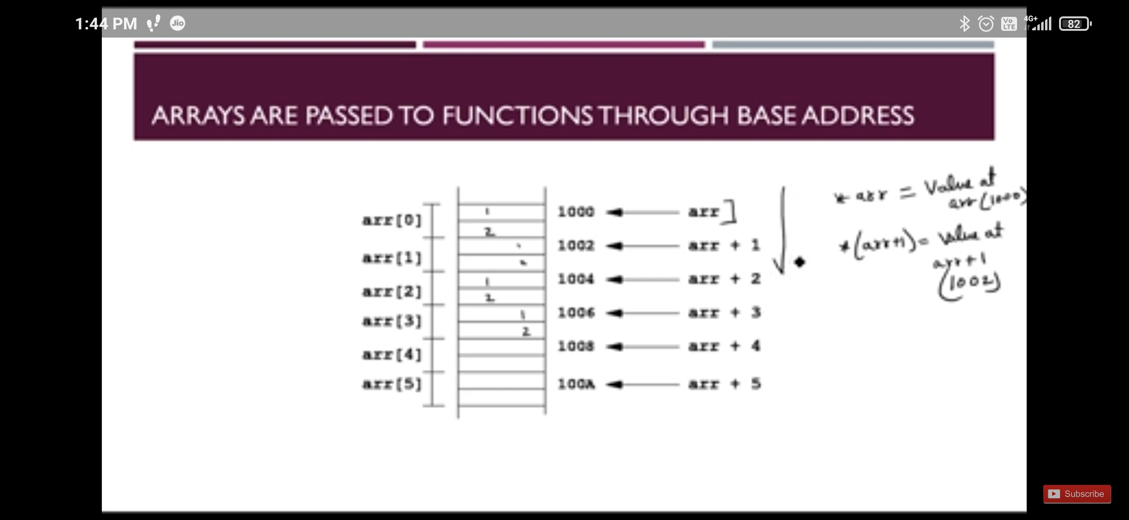
TUTORIAL 34

IS STRING A DATATYPE IN C

- No
- We hava char, int, float, and other data types but no ‘string’ in C
- String is not a supported data type in C but it is a very useful concept to model real world entities like name, city, etc.
    - Char name[12];
- We express strings using an array of characters terminated by a null character(“\0”).

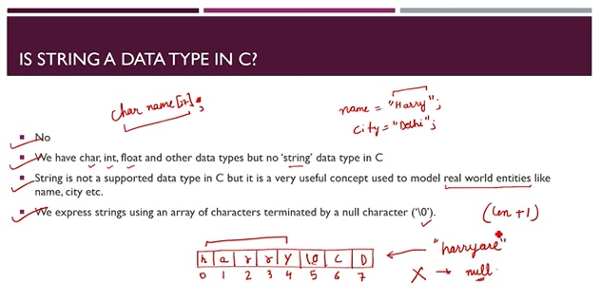
Note we use a character array of length = length of string + 1 only

WHAT ARE STRINGS IN C

- String array of characters terminated by NULL character
- Strings in C is created by creating an array of characters
- We need an extra character (‘\0’ or null character) to tell the compiler that the string ends here

CREATING STRINGS IN C

- We can create character array in the following ways:
  - Char name[] = “aryan” ;
  - Char name[] = {‘a’, ‘r’, ‘y’, ‘a’, ‘n’, ‘\0’}
      - In this method remember use single quote only

TAKING STRING INPUT FROM THE USER

Char str[52];
gets(str); // taking string input
printf(“%s”, str);
Puts(str); //printing string

TUTORIAL 34

WHAT ARE STRINGS IN C

- C language does not support strings as a data type
- We express strings using an array of characters terminated by a null character(‘\0’)
- We express strings using an array of characters terminated by a null character (‘\0’)
- String: array of characters terminated by NULL character
- We can create a character array using following ways:
    - Char name[] = “aryan;
    - Char name[] ={‘a’, ‘r’, ‘y’, ‘a’, ‘n’, ‘\0’};

C LIBRARY: <string.h>

Functions Use

stract() This function is used to concatenate or combine
Example: stract(“hello ”, “world”)

strlen() This function is used to show length of a string note that it wont calculate NULL character
Example: strlen()

strrev() shows the reverse of a string

strcpy(s2, s1) This is used to copy one string into another. Copies s1 to s2

strcmp() compare two given strings
Example: strcmp(“sold”, “thigh”) different compilers give different positive or negative values for different functions

TUTORIAL 37

WHAT IS A STRUCTURE IN C

- Structures are user defined data type in C
- Using structures allows us to combine data of different types together
- It is used to create a complex data type which contains diverse information
- They are very similar to arrays but structure can store data of any type, which is practically more useful

Example: storing employee information
- Structures are user defined data type
- Suppose we want to store information of 10,000 employees working at ABC pvt. Ltd
    - Name
    - Address
    - Email
    - Employee id
- Clearly we need some user defined data type which contains only this information.

DEFINING A STRUCTURE

struct Student
{
Int Id ;
Int marks ;
Char fav_char ;
};

//New data type student has been created

DECLARING ASTRUCTURE

#include <stdio.h>
struct Employee
{
Int id;
Char name[55];
Float marks;
} e1, e2 ;

int main()
{
return 0;
}

INITIALIZING A STRUCTURE

Method 1
Inside main()
Struct Employee e1 = {12, 34.50} ;

Method 2
Inside main()
struct Employee e1 ;
e1.id =12;
e1.marks = 12.50;

ACCESSING STRUCTURE MEMBER OPERATOR

- Array elements are accessed using subscript variable
- In a similar fashion, structure members are accesed using dot [.] operator.
- (.) is called as “structure member operator”
- To access the member of the structure, we use this operator in between “Structure name” & “member name”

TUTORIAL 39

WHAT IS A UNION

- Union is a user defined data type(very similar to structures)
- The difference between structures and unions is that in structure, each member has its own storage location, whereas members of a union uses a single shared memory location
- This single shared memory location is equal to the size of its largest data member
- This is better because we can save memory location by allocating the size of the largest element to the union and each of the element would use that location……

struct employee
{
Int id; // 4bytes
Char name [34]; // 34 bytes
};
Size = 38 bytes

struct activeEmployee
{
char prog[34];
char sweeper[34];
};
Size = 68 bytes

DECLARING AND ACCESSING UNION MEMBERS

- Like structures, we access any member by using the member access operator (.) in unions
- We use keyword union to define a union
- Syntax is very similar to that of structures

Union cannot handle all members at once

Union student
{
float marks; //4 bytes
Int id; //4 bytes
}s1;

SYNTAX FOR UNIUONS IS VERY SIMILAR TO STRUCTURES

union test{
int a;
int b;
char c;
} un;
un.a;
un.b;
un.c;
TUTORIAL 42

LOCAL VARIABLE (recap)
GLOBAL VARIABLE (recap)

NOTRE: If local variable and global variable both are used then function will work while taking local variable

STATIC VARIABLE
- Static variables are variables which have a property of preserving their values even when they go out of scope
- They preserve their value from the previous scope and are not initialized again
- Static variable remains in memory throughout the span of the program.
- Static variables initialized to 0 if not initialized explicitly
- In C, static variables can be initialized using constant literals.

SYNTAX:
Static data_type name = value;
- g: Static int harry = 7;

Static int b = func1(); //This gives compilation error because it needs a constant literal beforehand as it secures the size during compilation
TUTORIAL 45

DYNAMIC MEMORY ALLOCATION

WHAT AND WHY DYNAMIC MEMORY ALLOCATION
- An statically allocated variable or array has a fixed size memory.
- We have learnt to create big enough arrays to fit in our inputs but this doesn’t seem like an optimal way to allocate memory
- Memory is a very useful resource
- Clearly we need a way to request memory on runtime.
- Dynamic Memory allocation is a way in which the size of a structure can be changed during the runtime.

STATIC MEMORY ALLOCATION | DYNAMIC MEMORY ALLOCATION
Allocation before the program’s execution | Allocation is done during the program’s execution
There is no memory reusability and the memory allocated cannot be freed. | There is memory reusability and the allocated memory can be freedom when not required
Less Efficient | More efficient

MEMORY ALLOCATION IN C PROGRAMS
- Memory assigned to a program in a typical architecture can be broken down into four segments:
    - Code: text segment
    - Static/ global variables:
            - Data segment: initialized data storage
            - BSS segment: uninitialized segment
    - Stack: as the program moves forward. Stack works on lifo (last in first out)
    - Heap: dynamic memory allocation. It grows in direction opposite to stack.

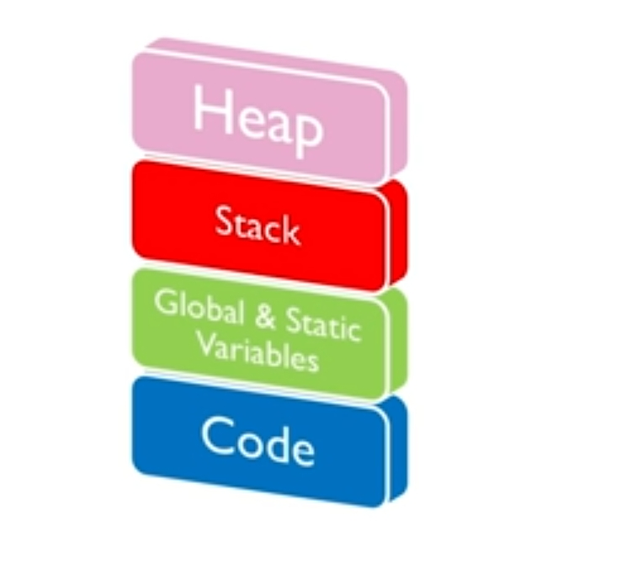
STACK OVERFLOW
- Compiler allocates some space for the stack part of the memory.
- When this space gets exhausted for some bad reason, the situation is called as stack overflow
- Typical example includes recursion with wrong/ no base condition

USE OF HEAP
- There are a lot of limitations of stack (static memory allocation).
- Some of the examples include variable sized array, freeing memory no longer required etc.
- Heap can be used flexibly by the programmer as per his needs

USING HEAP
- We can create a pointer in our main function and point to a memory block in the heap.
- The address is stored by the local variable in the main function.
- The memory consumed will not get freed automatically in case we overwrite the pointer.
TUTORIAL 47

FUNCTIONS FOR DYNAMIC MEMORY ALLOCATION
- In dynamic memory allocation , the memory allocated at runtime from the heap
- We have four functions that help us achieve this task:
  - malloc
  - calloc
  - realloc
  - free

MALLOC()
- malloc() stands for memory allocation
- It reserves a block memory with the given amount of bytes
- The return value is a void pointer to allocated space
- Therefore the void pointer needs to be casted to the appropriate types as per the requirements
- However, if the space is insufficient, allocation of memory fails and it returns a NULL pointer.
- All the values at allocated memory are initialized to garbage values.
    - Syntax:
        - int *ptr;
        - ptr = (int*)malloc(3* sizeof(int));

CALLOC
- calloc() stands for contiguous allocation.
- It reserves n blocks of memory with the given amount of bytes.
- The return values is a void pointer to the allocated space.
- Therefore the void pointer needs to be casted to the appropriate type as per the requirements
- However, if the space is insufficient, allocation of memory fails and it returns a NULL pointer
- All the values at allocated memory are initialized to 0.
    - Syntax
      - (ptr-type*) calloc(n, size_in_bytes);

REALLOC()
- realloc() stands for reallocation
- If the dynamically allocated memory is insufficient we can change the size of the previously allocated memory using realloc() function
- Syntax:
  - ptr = (ptr-type) realloc(ptr, new_size in_bytes);

FREE()
- free() is used to free allocated memory
- If the dynamically allocated memory is not required anymore. We can free it using free function
- This will free the memory being used by the program in the heap
- Syntax:
  - free(ptr);
TUTORIAL 49

WHAT IS STORAGE CLASS?

- A storage class defines scope, default initial value & lifetime of a variable.
- In previous lectures we saw that Dynamic Memory Allocation is a way in which the size of a data structure can be changed during the runtime
- A storage class defines following attributes about a variable in C:
    - Scope
    - Default initial value: like int is an initial value
    - Lifetime

STORAGE CLASS IN C
- In C language, following storage classes are most often used:
    - Automatic Variables
    - External Variables
    - Static Variables
    - Register Variables

AUTOMATIC VARIABLES: AUTO STORAGE CLASS
- Scope: Local to the function body they are defined in.
- Default Value: Garbage value(a random value)
- Lifetime: Till the end of the function block they are defined in
- A variable defined without any storage class specification is by default an automatic variable
- int harry and auto int harry are same

EXTERNAL VARIABLES: EXTERNAL STORAGE CLASS
- They are same as global variables
- Scope: global to the program they are defined in
- Default Initial Value: 0
- Lifetime: These variables are declared outside any function. They are available throughout the lifetime of the program.
- A global variable can be changed by any function in the program
- Int harry written outside any function will tell compiler that harry is a global variable
- It is recommended to minimize the use of unnecessary global variables in a program

EXTERNAL VARIABLE: EXTERN VARIABLE
- External keyword is used to inform our C compiler that a given variable is declared somewhere else.
- Using extern will not allocate space for the variable
- Example:
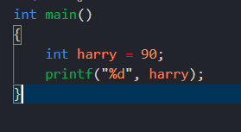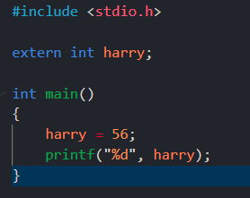
HARRY.C MAIN.C

STATIC VARIABLES: STATIC STORAGE CLASS
- Scope: Local to the block they are defined in
- Default Initital Value: 0
- Lifetime: They are available throughout the lifetime of the program
- A static variable remain under existence for use within the function for entire program run.
- Static int harry written inside any function will tel compiler that harry is a static variable
- It is recommended to minimize the use of unnecessary static variable in a program.

REGISTERED VARIABLES: REGISTER STORAGE CLASS
- Scope: Local to the fi=unction they are declared in
- Default initital value: garbage value
- Lifetime: they are available till the end of the function block, in which the variable is defined.
- REgister variables requests the compiler to store the variable in the CPU register instead of storing in the memory to have faster access.
- Generally this is done for the variables which are being used frequently
TUTORIAL 52

WHAT IS A VOID POINTER

- A void pointer is a pointer that has no data type associated with it.
- A void pointer can be easily typecasted to any pointer type.
- In single language it is a general purpose pointer variable.

VOID POINTER: C PROGRAM

- A void pointer is a pointer that has no datatype associated with it
- A void pointer can be easily typecasted to any pointer

int x = 10;
int y = ‘x’;
void *p = &x; // void pointer stores address of int ‘x’
p = &y; // void pointer holds address of char ‘y’

USES OF VOID POINTER

General purpose pointer variable
- In dynamic memory allocation, malloc() and callloc return (void*) type pointer
- This allows these dynamic memory functions to be used to allocate memory of any data type. This is because these pointers can be typecasted to any pointer data type.

MORE ON VOID POINTER

- It is not possible to dereference void pointer directly.
- Pointer arithmetic is not allowed in C standards with void pointers
- Hence it is not recommended to use pointer arithmetic which void pointers.

TUTORIAL 53

NULL POINTER IN C
- Null pointer is a pointer which has a value reserved for indicating that the pointer or reference does not refer to a valid pointer
- A null pointer is guaranteed to compare unequal to any pointer that points to a valid object.
- Dereferencing a null pointer is undefined behavious in C, and a conforming implementation is allowed to assume that any pointer that is dereferenced is not null.

WHAT IS A NULL POINTER
- Null pointer is a pointer which has a value reserved for indicating that the pointer or reference does not refer to a valid object
- A null pointer is guaranteed to compare unequal to any pointer that points to a valid object
- NULL pointer is a specific pointer which is mentioned in C standard and it has specific purpose
- NULL pointer gives a functionality to C program to check whether a pointer is legitimate or not.

NULL POINTER: C PROGRAM

- A check must be run by the programmer to know whether a pointer is null before dereferencing it.
int x = 10;
int *p = NULL; //NULL POINTER
p = &x; //Null pointer now holds address of int x’

USES OF NULL POINTER

- To initialize a pointer variable in cases where pointer variable has not been assigned any valid address yet
- To check for legitimate address location before accessing any pointer variable.
- By doing doing so, we can perform error handling while using pointers with c.
- Example of such error handling can be: dereference pointer variable only if it’s not NULL
- To pass a null pointer to a function argument when we do not want to pass any valid memory address.

MORE ON NULL POINTERS
- Null macro is defined as ((void*)0) in header files of most of the C compiler implementation
- NULL pointer vs Uninitialized pointer: An unitialized pointer contains an undefined value
- A null pointer stores a defined value, which is the one decide by the environment to not be a valid memory address for any object.
- NULL vs void pointer: Null pointer is a value whereas void is a type
TUTORIAL 54

DANGLING POINTER

WHAT IS A DANGLING POINTER {dangling = hanging}
- A pointer to a freed memory location or the location whose content has been deleted is called a dangling pointer.
- Dangling pointers arise during object destruction when an object that has an incoming reference is deleted or deallocated, without modifying the value of the pointer, so that the pointer still points the memory location of the deallocated memory

CAUSES OF DANGLING POINTER
- Deallocation of the memory
- Returning local variables in function calls
- Variable going out of scope

DEALLOCATION OF MEMORY
- When memory is deallocated, the pointer keeps pointing to the freed space.
- Example:
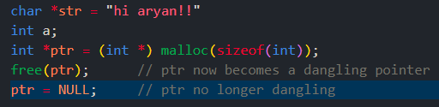

RETURNING LOCAL VARIABLES IN FUNCTION CALLS
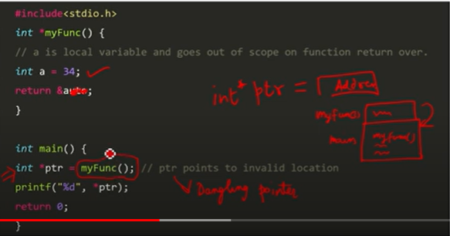
VARIABLE GOING OUT OF SCOPE
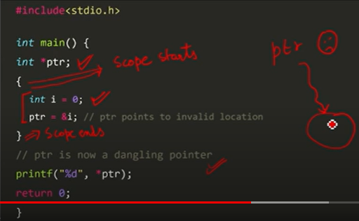

IS DANGLING POINTER A GOOD THING TO HAVE?
- Dangling pointers can introduce nasty bugs in our C programs.
- Dangling pointer bugs frequently become security holes at times.
- We can avoid issues caused by dangling pointers by initializing pointer to NULL.
- After de-allocation memory, pointer will be no longer dangling.
- Assigning NULL value means pointer is a null pointer now.
TUTORIAL 55

WHAT IS A WILD POINTER
- Uninitialized pointers are known as wild pointers
- These pointers point to some arbitrary memory location in memory and may cause a program to crash or behave badly
- Dereferencing wild pointers can cause nasty bugs
- It is suggested to always initialize unused pointer to NULL

An Example
In the following program is a wild pointer until it is given the address of a.

int a;
int* ptr; // wild pointer
ptr = &a; // pointer no longer wild
TUTORIAL 58

PREPROCESSOR IN C

QUICK RECAP:
- Compiler converts textual form into an executable.
- There Are 4 phases of a C program for a C program to become an executable:
    - PreProcessing:
        - Removal of comments
        - Expansion of macros
        - Expansion of include files
    - Compilation
        - Assembly level instructions are generated
    - Assembly
        - .o, .exe files are generated
        - printf and all are not resolved
        - Assembly level instructions are converted to machine code
    - Linking
        - Links the function implementations

WHAT IS A C PREPROCESSOR
- C preprocessor comes under action before the actual compilation process
- C preprocessor is not a part of the c compiler
- It is a text substitute tool
- All preprocessor commands begin with a hash symbol (#)
- Some examples of preprocessor commands
      - #define
      - #include
      - #undef
      - #ifdef
      - #ifndef
      - #if: If any compiletime condition is true
      - #else
      - #elif
TUTORIAL 59

#INCLUDE AND #DEFINE PREPROCESSOR IN C

THE #INCLUDE DIRECTIVE

- The # include directive causes the preprocessor to fetch the contents of some other file to be included in the present file
- This file may in turn #include some other files which may in turn do the same
- Most commonly the #include files have a .h extension indicating that they are header files

TWO COMMON #ICLUDE FORMATS
- In C programming there are two common formats for #include:
    - #include <header_file.h> // the angle braces say to look in the standard system directories
    - #include “myFile.h” // The quotation marks say to look in the current directory
- Disk drive full path allowed, but discouraged since it is not portable
    - #include <C:\Program Files\Harry\some.h> //Too specific
    - #include <sysfile.h> // Relative and portable path to the standard locations

THE #DEFINE DIRECTIVE
- The #define directiveis used to “define” preprocessor “variables”
- The #define preprocessor directive can be used to globally replace a word with a number
- It acts as if an editor did a global search-and-replace edit of the file.

USING #DEFINE FOR DEBUGGING
- #define directive can be used for debugging
- We can have pricing statements that we only want active when debugging We can protect them in a ifdef block as follows:
    - #define debug
    - #ifdef debug
      - [print statement]
    - #endif
    - #undef debug

MACROS USING #DEFINE
- We can also create macros using #define
- Macros operate much like functions. But because they are expanded in place and are generally faster
#define pi 3.14
#define square(x) x*x // macro

Area = pi *square(side)
TUTORIAL 60

OTHER DIRECTIVES AND PREDEFINED MACROS

OTHER C PREPROCESSORS
- #undef : undefines a macro
- #ifdef : returns true if a preprocessor variable or maro is defined
- #ifndef : if not defined
- #endif
- #if
- #else
- #elif
- #Pragma : To issue some special command to the compiler

PREDEFINED MACROS IN C
- __DATE__
        - The current date as character literal in “MMM DD YYYY” format
- __TIME__
        - This contains the current time as a character literal in “HH:MM:SS” format
- __FILE__
        - The current filename as a string literal
- __LINE__
        - The current line number as a decimal constant
- __STDC__
        - Define as I(one) when the compiler compiles with ANSI standard
TUTORIAL 62

I/O FILE

WHY DO WE NEED A FILE?
- Files are used to store data and information
- Files are used to read and access the data anytime from the hard disk
- Files make it easy for a programmer to access and store content without losing it on program termination

VOLATILE VS NON VOLATILE MEMORY
VOLATILE MEMORY | NON-VOLATILE MEMORY
Volatile memory is computer storage that only maintains its data while the device is powered. | Non-volatile memory is computer memory that can retain the stored information even when not powered.
The RAM will hold data, programs and information as long as it has a constant power supply but just as the power is inturrupted the data is cleared | The type of memory is also reffered to as permanent memory since data stored within it can be retrieved even when there is no constant power supply.
The volatile memory will only hold the data temporarily. | It is used for long-term storage of data

WHY DO WE NEED?

- When a C program is terminated, the data in ram is lost.
- Storing in a file will preserve our data even after the program is terminates
- Ram is not able to handle quite large amount of data due to its small size relative to the hard disk.
- It is easy to transfer data as files

TYPES OF FILES
- There are two types of files
- Binary files

FILE OPERATION IN C
- In C we can perform these high level operation of files:
    - Creating a new file
    - Opening a file
    - Closing a file
    - Reading from and writing to a file
TUTORIAL 64

WORKING WITH FILES IN
- When working with files, we have to declare a pointer of type FILE
- This declaration helps us to work with files through C program

FILE *ptr = NULL

OPENING A FILE- CREATING OR EDITING A FILE
- Stdio.h contains a function for opening files in C.
- The syntac for opening a file in standard I/O is:
    - ptr = fopen(“file.txt”, “mode”)
- For Example:
    - Fopen(“E:\\aryan\aryan.txt”, “w”)
    - Fopen(“E:\\aryan\aryan.bin”, “wb”)

CLOSING A FILE
- Any file which is opened in a C progeam needs to be closed
- Closing a fileis accomplished by the library function fclose()
- Fclose(fptr); //fptr is the file pointer associated with file to be closed

READING A FILE
- In order to read a file, we can use fscanf function
- This function is file version of scanf function
- fscanf expects a file pointer in addition to the other arguments which scanf expects
- We will have to open the file in read mode in order to use this function

fscanf(ptr, “%s”, string)

WRITING TO A FILE
- In order to write to a file, we can use fprintf function.
- This function is file version of printf function
- Fprintf expects a file pointer in addition to the other arguments which printf expects
- We will have to open the file in writing mode in order to use this function
TUTORIAL 67

MORE ON FILE I/O

WORKING WITH FILES IN C
- Stdio.h contains a function called fopen() for opening files in C
- When working with files, we have to declare a pointer of type FILE
    - FILE *ptr = NULL;
    - ptr = fopen(“main.txt”, “r”)
- This declaration helps us to work with files through C program.
- The syntax for opening a file in standard I/O is:
    - ptr = fopen(“file.txt”, “mode”);
- In order to read/ write to a file, se can use fscan/ fprintf function
    - Fscanf(ptr, “%s”, buff); fprintf(fptr, “Marks = %d”, salary);
- Fclose(ptr); //fptr is the file pointer associated with file to be closed

MODE AND DESCRIPTION
MODE | DESCRIPTION
r | Opens an existing text file for reading
w | Opens a file for writing in appending mode. If it does not exist, then a new file is created. Writing from the beginning of the file
a | Opens a text file for writing in appending mode. If it does not exist, then a new file is created. The program will start appending content to the existing file content
r+ | This mode will open a text file for both reading and writing
w+ | Opens a text file for both reading and writing. It first truncates the file to zero length if it exists, otherwise creates a file if it exists, otherwise creates a file if it does not exist
a+ | Opens a text file for both reading and writing. It creates the file If it does not exist. The reading will start from the beginning but writing can only append to file

OTHER FILE I/O FUNCTIONS IN C
- There are various functions provided by C standard library to read and write a file, character, or in the form of a fixed length string
- Some of them are(c is for character and s is for string):
    - fputc
    - fputs
    - fgetc
    - fgets

FPUTC FUNCTION IN C
- Simplest function to write characters to a file is fputc
- Syntax of fputc goes as follows:
    - int fputc(character, FILE pointer);
    - int returns the written character written on success
    - On failure it returns EOF(end of file character)
    - THe EOF is a constant defined in the header file stdio.h

FPUTS IN C
- fputs function is used to write a null terminated string to a file in c
    - int fputs(const char*s, FILE *ptr);

FGETC FUNCTION IN C
- Simplest function to read characters from a file is fgetc
- Syntax of fgetc goes as follows:
    - int fgetc(FILE *fptr);
    - It returns the read character on success
    - On failre it returns EOF
    - The EOF is a constant defined in the header file stdio.h

FGETS IN C
- fgets function is used to read a null terminated string to a file in c
    - int fgets(const char *s, int n,FILE* ptr);
TUTORIAL 68

COMMAND LINE ARGUMENTS IN C

WHAT ARE COMMAND LINE ARGUMENTS
- Command line argument is an important concept in C programming.
- Sometimes we need to pass arguments from the command line to the program a set of inputs.
- Command line arguments are used to supply parameters to the program when it is invoked.
- It is mostly used when you need to control your program from the console.
- These arguments are passed to the main() method.

COMMAND LINE EXAMPLE

- ffmpeg is a free and open-source project consisting of a vast software suite of libraries and programs for handling video, audio, and other multimedia files and streams.
- ffmpeg.exe is a command line utility written in c language.
- Other examples include git, brew, apt-get etc.

SAMPLE PROGRAM
#include <stdio.h>

int main(int argc, char *argv[])
{
printf("argc is %d\n", argc); //If no arguments are passed then argc = 1
if (argc >= 2)
{
printf("The arguments supplied are:\n");
for (int i = 0; i < argc; i++)
{
printf("%s\t", argv[i]);
}

}
return 0;
}

TUTORIAL 72

FUNCTION POINTERS

- We can have pointers pointing to functions as well
- Function pointers are useful to implement callback functions
- Compiler takes one or more source files and converts them to machine code.
      - int (*p)(int, int); //declaration and definition
      - p = &func1;

TUTORIAL 73

USING FUNCTION POINTERS

FUNCTION POINTERS
- We can have pointers pointing to code and not data
- Function pointers point to code and not data
- Function pointers are useful to implement callback functions
- Unlike normal pointers we do not allocate de-allocate memory using function pointers.

CALLBACK FUNCTIONS

- Function pointers are used to pass a function to a function
- This passed function can then be called again(hence the name callback function).
- This provides programmer to write less code and to do more stuff
TUTORIAL 75

MEMORY LEAK IN C

WHAT IS MEMORY LEAK IN C
- Dynamic memory allocation is a way in which the size of a data structure can be changed during the runtime.
- Memory assigned to a program in a typical architecture can be broken down into four segments:
    - Code
    - Stack/global variables
    - Stack
    - Heap

WHAT CAUSES MEMORY LEAK IN C?
- With great power comes great responsibility
- Memory leak is caused when we don’t use dynamic memory properly
- When we keep on allocating memory in the heap without freeing the overall memory usage keeps on increasing.
- This situation is the cause of memory leak ie the programmer creates a memory block in the memory and forgets to deleteit/
- To avoid these memory leak situations, memory allocation on heap should always be freed when not needed.

